**Creative Brief**

Victoria Shi

11/18/2020

**Project Title: Marie Curie Website**

1. **Project Overview**

The goal of this website is to be informative and highlight the main research discoveries of Marie Curie that lead her to win 2 Nobel Prizes (the only person to do so in two scientific fields). I would also like to focus on her efforts to overcome gender stereotypes as a female researcher and xenophobia (as a foreigner) in France.

1. **Resources**

Context text and some photos will be edited and referenced from <https://en.wikipedia.org/wiki/Marie_Curie>. Additional photos will be sourced from Google

1. **Audience**

This will be an informational site with not commercial promotion. This will be part of my portfolio and so instructors and prospective clients will likely see it. The website will be appropriate for all demographics, but the information will likely appeal to students interested in science, especially female students and other underrepresented groups in STEM and research.

1. **Message**

I would like to focus on Marie Curie’s legacy as the first female to win a Nobel Prize and for her important contributions to chemistry and physics. She also has made some contributions during WW1 and was noted to have a modest lifestyle.

1. **Tone**

The tone for this website will be of admiration and respect. I hope to inspire students especially those of females/underrepresented groups to overcome obstacles and preserve doing what they enjoy.

1. **Visual style**

I’m leaning towards a more historical, black and white feel (at least for the homepage as I imagine there to be a black and white photo of her). I would also love to have the subpages to be inspired by a scientific journal with footnotes and citations (that would be from the Wikipedia page) (see below). Page design could also have influences of Marie Curie’s journal entries and look like a lab journal.

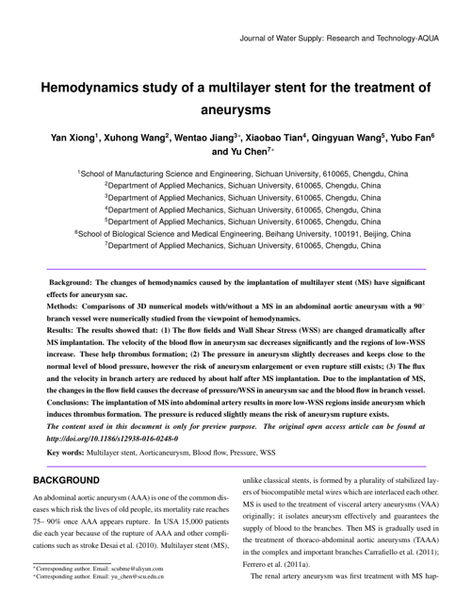

This may be too visually dense for a webpage as I don’t have to include to much information from the Wikipedia page so instead the page design may just mimic the format of a scientific journal article (rather than all of it)

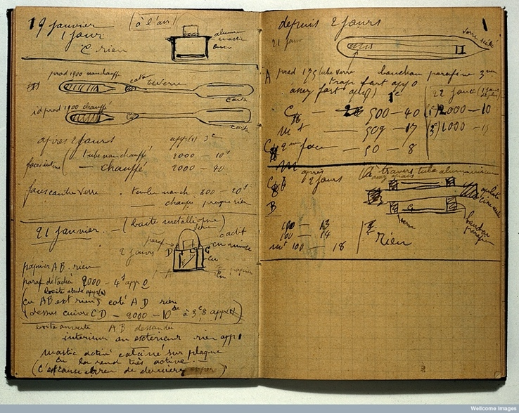 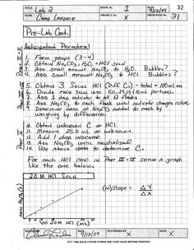

This is one of Marie Curie’s journal entries (left). Visually I don’t think this would be the most clear and appropriate for a website but this could be used as images within a webpage. I imagine that the website background could be like a lab notebook page (similar color, gird pattern and header design as seen in the right image).

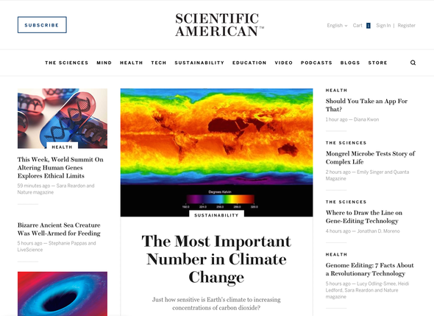

I really like this website layout of Scientific American (a contemporary science journal). I enjoy the modern and simple visual style. I think generally visual styles of scientific paper are no-frill and more to the point, which would be a guiding principle for this webpage as well.